

There are two ways of modifying bootstrap5

1) BY CDN LINK

2) BY DOWNLOADED BOOTSTRAP

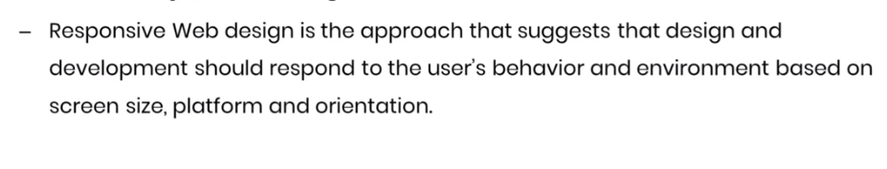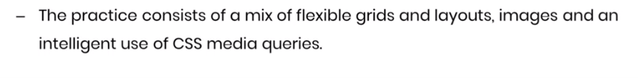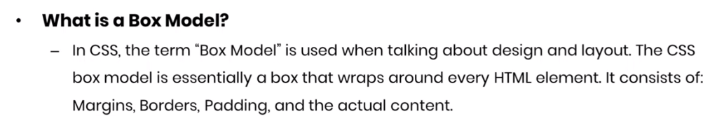

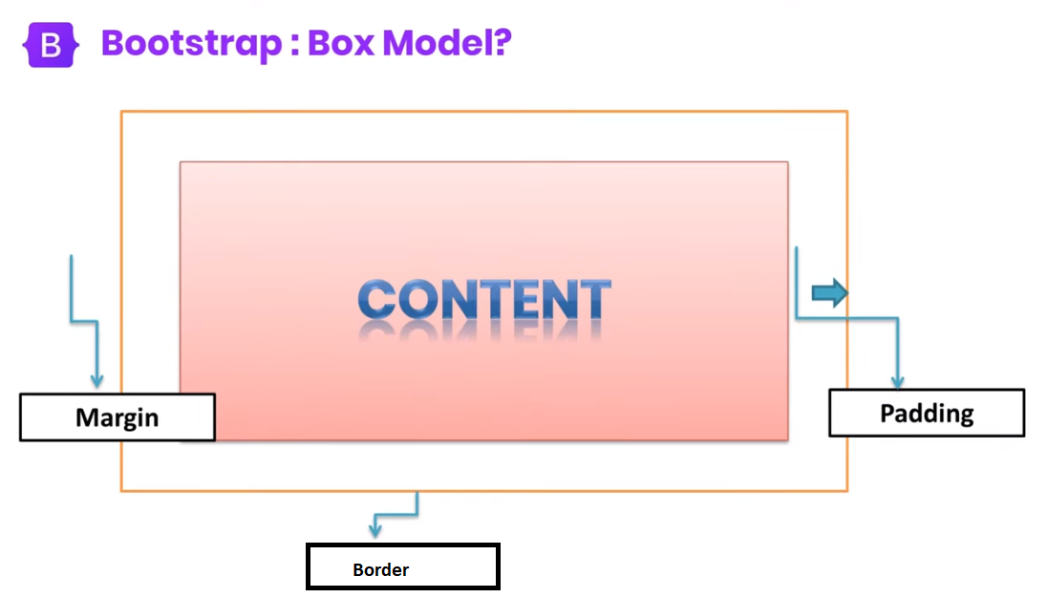

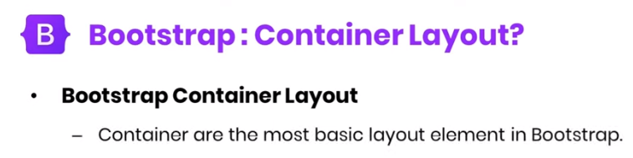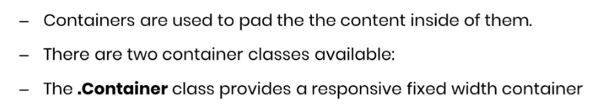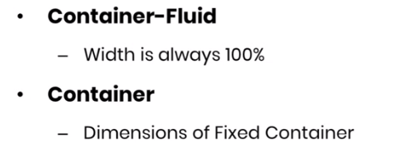

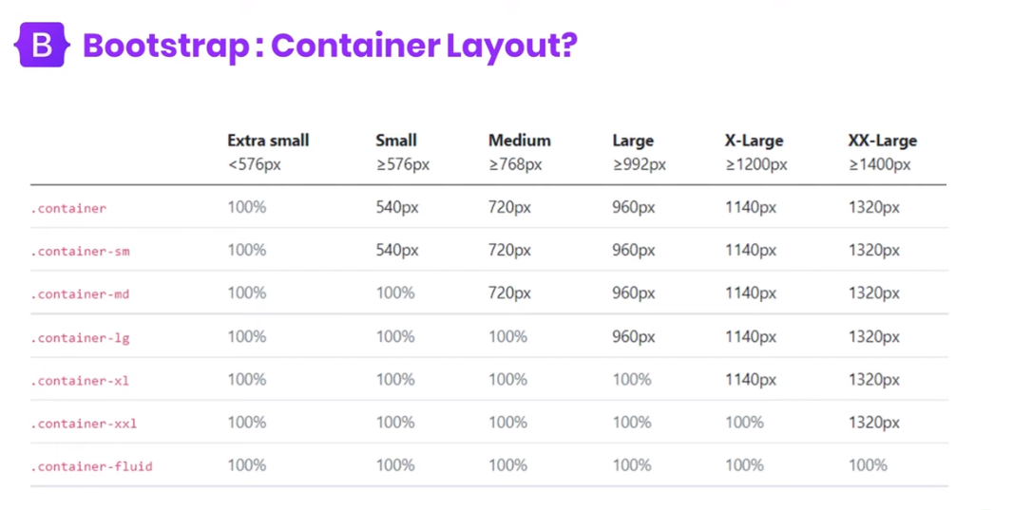

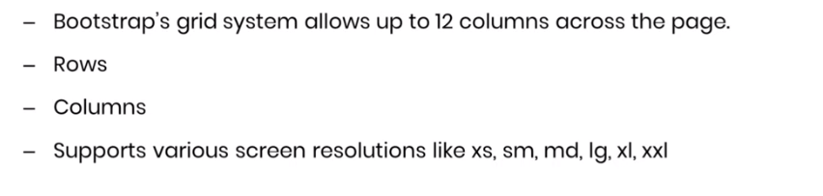



|  |  |  |  |  |  |  |  |  |  |  |  |
| --- | --- | --- | --- | --- | --- | --- | --- | --- | --- | --- | --- |
|  |  |  |  |  |  |  |  |  |  |  |  |

|  |
| --- |
| Col-12 |

|  |  |
| --- | --- |
| Col-4 | Col-8 |

|  |  |  |
| --- | --- | --- |
| Col-4 | Col-4 | Col-4 |

|  |  |  |  |
| --- | --- | --- | --- |
| Col-3 | Col-3 | Col-3 | Col-3 |

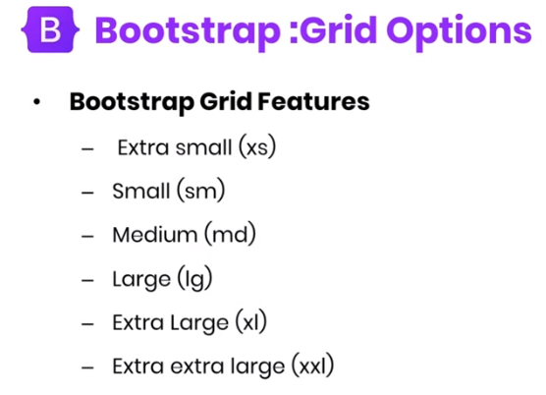

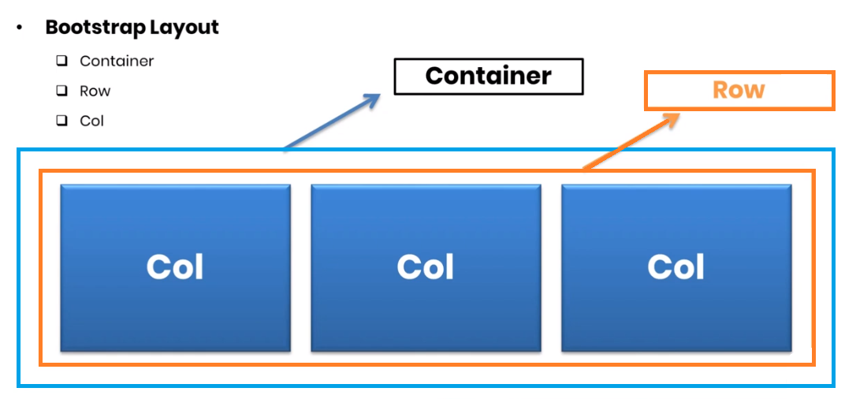

**OFFSET CLASSES**

Offset-xxl

Offset-xl

Offset-lg

Offset-md

Offset-sm

0-11

**ORDER CLASSES**

Order-first

Order-last

**TYPOGRAPHY IN BOOTSTRAP5**

**H1, h2, h3, h4, h5, h6**

 <p class="h1">Lorem, ipsum dolor sit amet consectetur adipisicing elit. Possimus placeat laborum quasi consequatur unde id nulla, quo cumque beatae distinctio. Nemo alias quasi commodi eveniet tenetur veniam deserunt, distinctio rerum!</p>

   <h1 >h1</h1>

    <h1 >h2</h1>

    <h1 >h3</h1>

    <h1 >h4</h1>

    <h1 >h5</h1>

    <h6 >h6</h6>

**Small tag in bootstrap5**

    <h1>h1  <small>small</small>  </h1>

**display-1 , display-2, display-3, display-4, display-5, display-6**

   <h1 class="display-1">h1</h1>

    <h1 class="display-2">h2</h1>

    <h1 class="display-3">h3</h1>

    <h1 class="display-4">h4</h1>

    <h1 class="display-5">h5</h1>

    <h1 class="display-6">h6</h1>

**mark tag in bootstrap5**

 <p >Lorem, ipsum dolor sit amet <mark>adipisicing elit. Possimus placeat laborum quasi consequatur</mark>  unde id nulla, quo cumque beatae distinctio. Nemo alias quasi commodi eveniet tenetur veniam deserunt, distinctio rerum!</p>

**abbr tag in bootstrap5**

    <p>My name is <abbr title="Nimra Mughal">NM</abbr></p>

**blockquote in bootstrap5**

 <div class="container">

        <blockquote class="blockquote">

            <p>Lorem ipsum dolor sit amet consectetur adipisicing elit.

Totam assumenda ipsam ut. Soluta cupiditate suscipit illum

eos earum? Quisquam quod, corporis voluptas iure maiores

harum? Exercitationem fugit tenetur enim quod?</p>

            <footer class="blockquote-footer">Nimra Mughal</footer>

        </blockquote>

    </div>

**dl in bootstrap5**

dl defines description list

dt define term

dd define description

  <dl>

    <dt>Cofee</dt>

    <dd>My everything</dd>

  </dl>

**Kbd in bootstrap5**

         <p>Use <kbd>ctrl + s</kbd> to open the Print dialog box.</p>

**Text alignments in bootstrap5**

Text-center

Text-start

Text-end

**List classes in bootstrap5**

List-unstyled

List-inline

**Badge in bootstrap5**

<button type="button" class="btn btn-primary">

Notifications <span class="badge bg-secondary">4</span>

</button>

<button type="button" class="btn btn-primary position-relative">

Inbox

<span class="position-absolute top-0 start-100 translate-middle badge rounded-pill bg-danger">

99+

<span class="visually-hidden">unread messages</span>

</span>

</button>

<button type="button" class="btn btn-primary position-relative">

Profile

<span class="position-absolute top-0 start-100 translate-middle p-2 bg-danger border border-light rounded-circle">

<span class="visually-hidden">New alerts</span>

</span>

</button>

**Breadcrumbs divider in bootstrap5**

<nav style="--bs-breadcrumb-divider: '>';" aria-label="breadcrumb">

<ol class="breadcrumb">

<li class="breadcrumb-item"><a href="#">Home</a></li>

<li class="breadcrumb-item active" aria-current="page">Library</li>

</ol>

</nav>

**PlaceHolder in bootstrap5**

<span class="placeholder col-6"></span>

<span class="placeholder w-75"></span>

<span class="placeholder" style="width: 25%;"></span>

**Color Class IN BOOTSTRAP5**

class="text-muted"

class="text-primary"

class="text-success"

class="text-info"

class="text-warning"

class="text-danger"

class="text-secondary"

class="text-dark"

class="text-body"

class="text-light"

class="text-white"

**Background Colors IN BOOTSTRAP5**

class="bg-primary p-3"

class="bg-success p-3"

class="bg-info p-3"

class="bg-warning p-3"

class="bg-danger p-3"

class="bg-secondary p-3"

class="bg-dark p-3"

class="bg-light p-3"

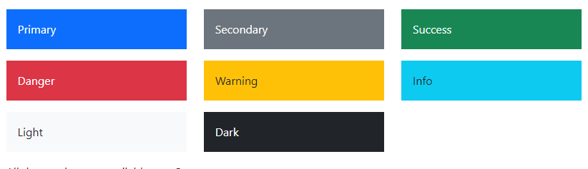

**Text Background Colors IN BOOTSTRAP5**

class="text-bg-primary"

class="text-bg-success"

class="text-bg-info"

class="text-bg-warning"

class="text-bg-danger"

class="text-bg-secondary"

class="text-bg-dark"

class="text-bg-light"

**Margin & Padding in Bootstrap5**

Where *property* is one of:

* m - for classes that set margin
* p - for classes that set padding

Where *sides* is one of:

* t - for classes that set margin-top or padding-top
* b - for classes that set margin-bottom or padding-bottom
* s - (start) for classes that set margin-left or padding-left
* e - (end) for classes that set margin-right or padding-right
* x - for classes that set both *-left and *-right
* y - for classes that set both *-top and *-bottom
* blank - for classes that set a margin or padding on all 4 sides of the element

Where *size* is one of:

* 0 - for classes that eliminate the margin or padding by setting it to 0
* 1 - (by default) for classes that set the margin or padding to $spacer * .25
* 2 - (by default) for classes that set the margin or padding to $spacer * .5
* 3 - (by default) for classes that set the margin or padding to $spacer
* 4 - (by default) for classes that set the margin or padding to $spacer * 1.5
* 5 - (by default) for classes that set the margin or padding to $spacer * 3
* auto - for classes that set the margin to auto

**Basic Table Classes**

class="table "

class="table table-striped"

class="table table-bordered"

class="table table-hover"

class="table table-dark"

class="table table-borderless"

class="table table-dark table-striped"

class="table table-dark table-hover"

**Table Contextual Classes <tr>**

class="table-primary"

class="table-success"

class="table-danger"

class="table-info"

class="table-warning"

class="table-active"

class="table-secondary"

class="table-light"

class="table-dark"

**Table Head Color <thead>**

class="table-primary"

class="table-success"

class="table-danger"

class="table-info"

class="table-warning"

class="table-active"

class="table-secondary"

class="table-light"

class="table-dark"

**Table Responsive**

<div class=” table-responsive”></div>

table-responsive-sm

table-responsive-md

table-responsive-lg

table-responsive-xl

table-responsive-xxl

**Image Shapes**

class="rounded"

class="rounded-circle"

class="img-thumbnail"

**Aligning Image**

class="float-start"

class="float-end"

class="mx-auto d-block"

**Responsive Image**

class="img-fluid"

**Jumbotron**

 <div class="container">

  <div class="mt-5 p-5 bg-primary text-white rounded">

    <h1>Jumbotron Example</h1>

    <p>Lorem ipsum...</p>

  </div>

</div>

**Alerts in Bootstrap5**

.alert-success

.alert-info

.alert-warning

.alert-danger

.alert-primary

.alert-secondary

.alert-light

.alert-dark

**Alerts Link**

To create link alert use <a>

**Closing Alert**

<div class="alert alert-success alert-dismissible">  
  <button type="button" class="btn-close" data-bs-dismiss="alert"></button>  
  <strong>Success!</strong> This alert box could indicate a successful or positive action.  
</div>

**Animated Alert**

<div class="alert alert-success alert-dismissible fade show">  
  <button type="button" class="btn-close" data-bs-dismiss="alert"></button>  
  <strong>Success!</strong> This alert box could indicate a successful or positive action.  
</div>

**Button In Bootstrap5**

class="btn"  
class="btn btn-primary"   
class="btn btn-secondary"   
class="btn btn-success"   
class="btn btn-info"   
class="btn btn-warning"   
class="btn btn-danger"   
class="btn btn-dark"   
class="btn btn-light"   
class="btn btn-link"

 <a href="#" class="btn btn-primary">Shop Now</a>

  <button type="button" class="btn btn-danger">Shop Now</button>

  <input type="button" class="btn btn-dark" value="Shop Now">

**Outline Button**

class="btn btn-outline-primary"  
class="btn btn-outline-secondary"   
class="btn btn-outline-success"   
class="btn btn-outline-info"   
class="btn btn-outline-warning"   
class="btn btn-outline-danger"   
class="btn btn-outline-dark"   
class="btn btn-outline-light text-dark"

**Button Class(size)**

* btn-lg
* by default medium
* btn-sm

btn-block

<div class="d-grid">  
  <button type="button" class="btn btn-primary btn-block">Full-Width Button</button>  
</div>

Gap-3 in btn-block

<div class="d-grid gap-3">  
  <button type="button" class="btn btn-primary btn-block">Full-Width Button</button>  
  <button type="button" class="btn btn-primary btn-block">Full-Width Button</button>  
  <button type="button" class="btn btn-primary btn-block">Full-Width Button</button>  
</div>

disabled

active

**Spinner**

<div class="spinner-border"></div>

**Spinner Color**

<div class="spinner-border text-muted"></div>

**Spinner Growing**

<div class="spinner-grow text-muted"></div>

**Spinner Size**

<div class="spinner-border spinner-border-sm"></div>  
<div class="spinner-grow spinner-grow-sm"></div>

**Spinner Button**

<button class="btn btn-primary">  
  <span class="spinner-border spinner-border-sm"></span>  
</button>  
  
<button class="btn btn-primary">  
  <span class="spinner-border spinner-border-sm"></span>  
  Loading..  
</button>  
  
<button class="btn btn-primary" disabled>  
  <span class="spinner-border spinner-border-sm"></span>  
  Loading..  
</button>  
  
<button class="btn btn-primary" disabled>  
  <span class="spinner-grow spinner-grow-sm"></span>  
  Loading..  
</button>

**Pagination**

<ul class="pagination">  
  <li class="page-item"><a class="page-link" href="#">Previous</a></li>  
  <li class="page-item"><a class="page-link" href="#">1</a></li>  
  <li class="page-item"><a class="page-link" href="#">2</a></li>  
  <li class="page-item"><a class="page-link" href="#">3</a></li>  
  <li class="page-item"><a class="page-link" href="#">Next</a></li>  
</ul>

**Pagination:Active State**

<ul class="pagination">  
  <li class="page-item"><a class="page-link" href="#">Previous</a></li>  
  <li class="page-item"><a class="page-link" href="#">1</a></li>  
  <li class="page-item active"><a class="page-link" href="#">2</a></li>  
  <li class="page-item"><a class="page-link" href="#">3</a></li>  
  <li class="page-item"><a class="page-link" href="#">Next</a></li>  
</ul>

**Pagination:Disable State**

<ul class="pagination">  
  <li class="page-item disabled"><a class="page-link" href="#">Previous</a></li>  
  <li class="page-item"><a class="page-link" href="#">1</a></li>  
  <li class="page-item"><a class="page-link" href="#">2</a></li>  
  <li class="page-item"><a class="page-link" href="#">3</a></li>  
  <li class="page-item"><a class="page-link" href="#">Next</a></li>  
</ul>

**Pagination:Sizing**

<ul class="pagination pagination-lg">

<ul class="pagination pagination-sm">

**Pagination:Aligning**

<ul class="pagination justify-content-center">

<ul class="pagination justify-content-end">

**Pagination:Icons**

<li class="page-item">

<a class="page-link" href="#" >

<span aria-hidden="true">&laquo;</span>

</a>

</li>

<li class="page-item">

<a class="page-link" href="#" >

<span aria-hidden="true">&raquo;</span>

</a>

</li>

**breadcrumbs**

<ul class="breadcrumb">  
  <li class="breadcrumb-item"><a href="#">Photos</a></li>  
  <li class="breadcrumb-item"><a href="#">Summer 2017</a></li>  
  <li class="breadcrumb-item"><a href="#">Italy</a></li>  
  <li class="breadcrumb-item active">Rome</li>  
</ul>

**Tooltips**

<button type="button" class="btn btn-primary" data-bs-toggle="tooltip" title="Hooray!">Hover over me!</button>

<script>

var tooltipTriggerList = [].slice.call(document.querySelectorAll('[data-bs-toggle="tooltip"]'))

var tooltipList = tooltipTriggerList.map(function (tooltipTriggerEl) {

return new bootstrap.Tooltip(tooltipTriggerEl)

})

</script>

**Tooltips Positioning**

<a href="#" data-bs-toggle="tooltip" data-bs-placement="top" title="Hooray!">Hover</a>  
<a href="#" data-bs-toggle="tooltip" data-bs-placement="bottom" title="Hooray!">Hover</a>  
<a href="#" data-bs-toggle="tooltip" data-bs-placement="left" title="Hooray!">Hover</a>  
<a href="#" data-bs-toggle="tooltip" data-bs-placement="right" title="Hooray!">Hover</a>

**Collapse**

<a href="#demo" data-bs-toggle="collapse">Collapsible</a>  
  
<div id="demo" class="collapse">  
Lorem ipsum dolor text....  
</div>

**Basic Nav**

<ul class="nav">  
  <li class="nav-item">  
    <a class="nav-link" href="#">Link</a>  
  </li>  
  <li class="nav-item">  
    <a class="nav-link" href="#">Link</a>  
  </li>  
  <li class="nav-item">  
    <a class="nav-link" href="#">Link</a>  
  </li>  
</ul>

**Disable Nav Item**

  <li class="nav-item">  
    <a class="nav-link disabled" href="#">Disabled</a>  
  </li>

**Nav:Aligning**

<ul class="nav justify-content-center">

<ul class="nav justify-content-end">

**Nav:Vertical**

<ul class="nav flex-column">

**Nav:Tabs**

<ul class="nav nav-tabs">

active at least one <a>

**Nav:Pills**

<ul class="nav nav-pills">

active at least one <a>

**Nav:Justified Pills/Tabs**

<ul class="nav nav-pills nav-justified">  
<ul class="nav nav-tabs nav-justified">

**Nav:Pills with DropDown**

  <li class="nav-item dropdown">  
    <a class="nav-link dropdown-toggle" data-bs-toggle="dropdown" href="#">Dropdown</a>  
    <ul class="dropdown-menu">  
      <li><a class="dropdown-item" href="#">Link 1</a></li>  
      <li><a class="dropdown-item" href="#">Link 2</a></li>  
      <li><a class="dropdown-item" href="#">Link 3</a></li>  
    </ul>  
  </li>

**Nav:Tabs with DropDown**

  <li class="nav-item dropdown">  
    <a class="nav-link dropdown-toggle" data-bs-toggle="dropdown" href="#">Dropdown</a>  
    <ul class="dropdown-menu">  
      <li><a class="dropdown-item" href="#">Link 1</a></li>  
      <li><a class="dropdown-item" href="#">Link 2</a></li>  
      <li><a class="dropdown-item" href="#">Link 3</a></li>  
    </ul>  
  </li>

**Nav:Toggleable/Dynamic Tabs**

<ul class="nav nav-tabs">  
  <li class="nav-item">  
    <a class="nav-link active" data-bs-toggle="tab" href="#home">Home</a>  
  </li>  
  <li class="nav-item">  
    <a class="nav-link" data-bs-toggle="tab" href="#menu1">Menu 1</a>  
  </li>  
  <li class="nav-item">  
    <a class="nav-link" data-bs-toggle="tab" href="#menu2">Menu 2</a>  
  </li>  
</ul>  
  
  
<div class="tab-content">  
  <div class="tab-pane container active" id="home">...</div>  
  <div class="tab-pane container fade" id="menu1">...</div>  
  <div class="tab-pane container fade" id="menu2">...</div>  
</div>

**Nav:Toggleable/Dynamic Pills**

<ul class="nav nav-pills">  
  <li class="nav-item">  
    <a class="nav-link active" data-bs-toggle="tab" href="#home">Home</a>  
  </li>  
  <li class="nav-item">  
    <a class="nav-link" data-bs-toggle="tab" href="#menu1">Menu 1</a>  
  </li>  
  <li class="nav-item">  
    <a class="nav-link" data-bs-toggle="tab" href="#menu2">Menu 2</a>  
  </li>  
</ul>  
  
  
<div class="tab-content">  
  <div class="tab-pane container active" id="home">...</div>  
  <div class="tab-pane container fade" id="menu1">...</div>  
  <div class="tab-pane container fade" id="menu2">...</div>  
</div>

**Navbar**

<nav class="navbar navbar-expand-sm bg-light">  
  <div class="container-fluid">  
    <ul class="navbar-nav">………</ul>  
  </div>  
</nav>

**Navbar:Color**

.bg-primary

.bg-success

.bg-info

.bg-warning

.bg-danger

.bg-secondary

.bg-dark

.bg-light

**Navbar:Brand-Logo**

<nav class="navbar navbar-expand-sm bg-dark navbar-dark">  
  <div class="container-fluid">  
    <a class="navbar-brand" href="#">Logo</a>  
  </div>  
</nav>

**Form:Vertical**

    <div class="container">

        <div class="row">

            <div class="col-lg-12">

                <form action="">

                    <h1 class="text-center text-success">Login Form</h1>

                    <div class="form-group">

                        <label>Name :</label>

                        <input type="text" placeholder="Enter Your NAme" class="form-control">

                    </div>

                    <div class="form-group mt-3">

                        <label >Email :</label>

                        <input type="email" placeholder="Enter Your Email" class="form-control">

                    </div>

                    <div class="form-group mt-3">

                        <label >Password :</label>

                        <input type="password" placeholder="Enter Your Password" class="form-control">

                    </div>

  <div class="form-group">

                        <button type="button" class="btn btn-outline-success rounded-pill">Login</button>

                    </div>

                </form>

            </div>

        </div>

    </div>

**Form:Horizontal**

 <form class="d-flex">

       <label >Password:</label>

       <input type="password" placeholder="Enter Your Password" class="form-control">

 </form>

**Form:CheckBox**

<div class="form-check">

<label class="form-check-label" for="flexCheckChecked">

Checked checkbox

</label>

<input class="form-check-input" type="checkbox" checked>

</div>

**Form:Radio**

<div class="form-check">

<label class="form-check-label" for="flexCheckChecked">

Checked checkbox

</label>

<input class="form-check-input" type="checkbox" checked>

</div>

**Form:CheckBox**

 <div id="demo" class="carousel slide" data-bs-ride="carousel">

    <!-- <div class="carousel-indicators">

      <button type="button" data-bs-target="#demo" data-bs-slide-to="0" class="active"></button>

      <button type="button" data-bs-target="#demo" data-bs-slide-to="1"></button>

      <button type="button" data-bs-target="#demo" data-bs-slide-to="2"></button>

    </div>

    <!-- The slideshow/carousel -->

    <div class="carousel-inner">

      <div class="carousel-item active">

        <img src="ban.PNG" alt="Los Angeles" class="d-block" style="width:100%">

      </div>

      <div class="carousel-item">

        <img src="lp.jpg" alt="Chicago" class="d-block" style="width:100%">

      </div>

      <div class="carousel-item">

        <img src="ban.PNG" alt="New York" class="d-block" style="width:100%">

      </div>

    </div>

  </div>

**FontOwsome**

  <div class="alert alert-success" role="alert">

        <i class="fa-solid fa-circle-exclamation"></i>A simple success alert—check it out!

      </div>

**Accordion**

<div class="accordion" id="accordionExample">

            <div class="accordion-item">

              <h2 class="accordion-header" id="headingOne">

                <button class="accordion-button" type="button" data-bs-toggle="collapse" data-bs-target="#collapseOne" aria-expanded="true" aria-controls="collapseOne">

                  Accordion Item #1

                </button>

              </h2>

              <div id="collapseOne" class="accordion-collapse collapse show" aria-labelledby="headingOne" data-bs-parent="#accordionExample">

                <div class="accordion-body">

                  <strong>This is the first item's accordion body.</strong> It is shown by default, until the collapse plugin adds the appropriate classes that we use to style each element. These classes control the overall appearance, as well as the showing and hiding via CSS transitions. You can modify any of this with custom CSS or overriding our default variables. It's also worth noting that just about any HTML can go within the <code>.accordion-body</code>, though the transition does limit overflow.

                </div>

              </div>

            </div>

          </div>

**Modal**

<!-- Button to Open the Modal -->  
<button type="button" class="btn btn-primary" data-bs-toggle="modal" data-bs-target="#myModal">  
  Open modal  
</button>  
  
<!-- The Modal -->  
<div class="modal" id="myModal">  
  <div class="modal-dialog">  
    <div class="modal-content">  
  
      <!-- Modal Header -->  
      <div class="modal-header">  
        <h4 class="modal-title">Modal Heading</h4>  
        <button type="button" class="btn-close" data-bs-dismiss="modal"></button>  
      </div>  
  
      <!-- Modal body -->  
      <div class="modal-body">  
        Modal body..  
      </div>  
  
      <!-- Modal footer -->  
      <div class="modal-footer">  
        <button type="button" class="btn btn-danger" data-bs-dismiss="modal">Close</button>  
      </div>  
  
    </div>  
  </div>  
</div>

**Modal:Animated**

<div class="modal fade"></div>

**Modal:Size**

<div class="modal-dialog modal-sm">

<div class="modal-dialog modal-lg">

<div class="modal-dialog modal-xl">

**Modal:FullScreen**

<div class="modal-dialog modal-fullscreen">

.modal-fullscreen-sm-down

.modal-fullscreen-md-down

.modal-fullscreen-lg-down

.modal-fullscreen-xl-down

.modal-fullscreen-xxl-down

**Modal:Centered**

<div class="modal-dialog modal-dialog-centered">

**Modal:Scrolling**

<div class="modal-dialog modal-dialog-centered">

**OffCanvas**

<div class="offcanvas offcanvas-start" id="demo">  
  <div class="offcanvas-header">  
    <h1 class="offcanvas-title">Heading</h1>  
    <button type="button" class="btn-close text-reset" data-bs-dismiss="offcanvas"></button>  
  </div>  
  <div class="offcanvas-body">  
    <p>Some text lorem ipsum.</p>  
    <p>Some text lorem ipsum.</p>  
    <button class="btn btn-secondary" type="button">A Button</button>  
  </div>  
</div>  
  
<!-- Button to open the offcanvas sidebar -->  
<button class="btn btn-primary" type="button" data-bs-toggle="offcanvas" data-bs-target="#demo">  
  Open Offcanvas Sidebar  
</button>

    <nav class="navbar navbar-expand-lg bg-warning ">

        <div class="container">

          <a class="navbar-brand" href="#"><strong>Navbar</strong></a>

          <button class="navbar-toggler" type="button" data-bs-toggle="collapse"

data-bs-target="#navbarSupportedContent">

            <span class="navbar-toggler-icon"></span>

          </button>

          <div class="collapse navbar-collapse" id="navbarSupportedContent">

            <ul class="navbar-nav  ms-auto offset-5">

              <li class="nav-item">

                <a class="nav-link active" href="#">Home</a>

              </li>

              <li class="nav-item">

                <a class="nav-link" href="#">Link</a>

              </li>

              <li class="nav-item dropdown">

                <a class="nav-link dropdown-toggle" href="#" role="button" data-bs-toggle="dropdown"

aria-expanded="false">

                  Dropdown

                </a>

                <ul class="dropdown-menu">

                  <li><a class="dropdown-item" href="#">Action</a></li>

                  <li><a class="dropdown-item" href="#">Another action</a></li>

                  <li><hr class="dropdown-divider"></li>

                  <li><a class="dropdown-item" href="#">Something else here</a></li>

                </ul>

              </li>

              <li class="nav-item">

                <a class="nav-link disabled">Disabled</a>

              </li>

            </ul>

            <form class="d-flex" role="search">

              <input class="form-control me-2" type="search" placeholder="Search">

              <button class="btn btn-outline-success" type="submit">Search</button>

            </form>

          </div>

        </div>

      </nav>

<div class="container ">

<div class="row gy-3 my-3">

<div class="col-sm-6 col-md-4 col-lg-3">

<div class="card" style="width: 18rem; ">

<img src="/bootstape/perfume/Pure-Agarwood-Oud-Oil-Cambodi-Super-Huile-de-Oud-pure-Cambodge-Cambodia-12ml.png" class="card-img-top img-fluid" alt="...">

<div class="card-body">

<h5 class="card-title text-warning">OUD E Hindi</h5>

<p class="card-text">World Best fragrance Rs96,999</p>

<a href="#" class="btn btn-primary">Show More</a>

</div>

</div>

</div>

<div class="col-sm-6 col-md-4 col-lg-3">

<div class="card" style="width: 18rem; ">

<img src="/bootstape/perfume/fb6b3b9a63563ff2fadd668dedf356d4.jpg" class="card-img-top img-fluid" alt="...">

<div class="card-body">

<h5 class="card-title text-warning">Cool Water</h5>

<p class="card-text">World Best fragrance Rs12,899</p>

<a href="#" class="btn btn-primary">Show More</a>

</div>

</div>

</div>

<div class="col-sm-6 col-md-4 col-lg-3">

<div class="card" style="width: 18rem; ">

<img src="/bootstape/perfume/Ffl3YOSXwAMzWIq.jpg" class="card-img-top img-fluid" alt="...">

<div class="card-body">

<h5 class="card-title text-warning">Lemarc</h5>

<p class="card-text">World Best fragrance Rs15,999</p>

<a href="#" class="btn btn-primary">Show More</a>

</div>

</div>

</div>

<div class="col-sm-6 col-md-4 col-lg-3">

<div class="card" style="width: 18rem; ">

<img src="/bootstape/perfume/WHAT-IS-OUD-OIL.jpg" class="card-img-top img-fluid" alt="...">

<div class="card-body">

<h5 class="card-title text-warning">Hindi Oud</h5>

<p class="card-text">World Best fragrance Rs110,000</p>

<a href="#" class="btn btn-primary">Show More</a>

</div>

</div>

</div>

</div>

</div>